**WEEK 6**

**Create a react app and display the greetings message.**

**App.js**

import logo from './logo.svg';

import './App.css';

function App() {

  return (

    <>

    <h1> Welcome to the first session of React </h1>

    </>

  );

}

export default App;

***Run command***

**npx create-react-app appname**

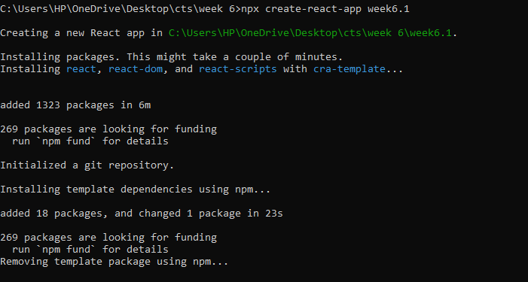

***To start the server***

**npm start**

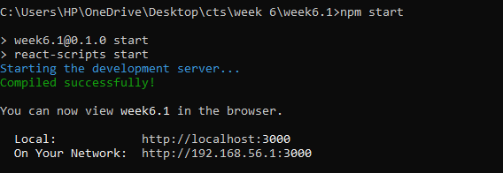

**OUTPUT**

